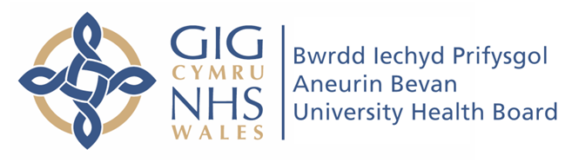

Blaenau Gwent West

Neighbourhood Care Network

Integrated Medium Term Plan

2021 -2024

Table of Contents
Executive Summary 3
1 Introduction to the Plan 9
2 Reflections on COVID-19 Pandemic Response 12
3 Reflections on the 2020 – 2023 Plan 16
4 Opportunities and Challenges for 2021-2024 21
5 Prioritised Actions 2021-2024 25
6 Estates Plan 32
7 Workforce Plan 38
8 Financial Plan 49
9 Strategic Alignment with Health Board Plans 54

Executive Summary
What is this section for?
Summary of the key points of the whole document, outlining the strategic direction of the area and highlighting key learning from the population needs assessment and asset profiles. Sharing the plan on a page as a high level summary of the actions to be taken forward in the next period.

This plan is our first annual ‘refresh’ of our inaugural 2020-2023 Integrated Medium Term Plan.
Nobody could have predicted when we developed our plans in the autumn of 2019, that in the first month of the financial year in 2020 we would be responding to a pandemic on the scale never before experienced within our lifetimes.
The starting point of the development of our 2021-2024 plan was a reflection on our progress in achieving our 2020-2023 plan and necessarily, our NCN response to the COVID-19 challenge.
We reflected that whilst the context we work in has significantly changed, the principles that underpin it remain.
What we aim to achieve hasn’t changed but the means to which we might achieve it have adapted against a backdrop of continued social distancing, anticipated further lockdowns and the impact that this might have on our population’s access to the services they require and ultimately their well-being.
We opted to consolidate our prioritised objectives, keeping the essence of the plan but recognising that some of our original objectives overlap and thus making the plan sharper and more focussed. Whilst included as an action within our last plan, we have highlighted ‘Improve access to Mental Health support for our population’ as a priority in its own right.
This is against a backdrop of our population needs assessment identifying that the Blaenau Gwent population has a poorer level of mental wellbeing than the average for Wales a whole and recognising the link between socio-economic deprivation and poor well-being/requiring treatment for mental health issues, conditions which will be further exacerbated by the consequences of COVID-19.
Our prioritised actions for 2021-2024 therefore are as follows:
- Responding to COVID19
- Improve wellbeing, health promotion and reduce preventable illness
- Building a compassionate community
- Improve access to Mental Health support for our population
- Develop well-being hubs in each of our places
- Improve access to services across the NCN
Our estate is a key enabler for the delivery of our place-based vision across Blaenau Gwent, which for our NCN, focusses around our two ‘places’ ; Ebbw Vale and Tredegar.

Blaenau Gwent West NCN has access to a wealth of estate both within the Health Service, the Local Authority and within the community.
The Transformation Model in Primary Care, with its onus on multidisciplinary team working, has been embraced within the NCN in recent years. However, the primary care estate has long been a barrier to realising its full potential. Plans for the development of new wellbeing hubs in both Tredegar (ongoing development) and Ebbw Vale (scoping stage), alongside existing estate in a hub and spoke model, are progressing at pace. It is intended that these developments will help services to work in a more cohesive, integrated manner to meet the needs of the population.
Delivery of our plan relies on having a sustainable workforce and third sector provision that can meet the increasing demands upon primary care and community services.
Recognising our issues regarding GP sustainability, rapid implementation of the Primary Care Model for Wales has been supported via transformation funding to test new models of care. Within Blaenau Gwent, this has focussed upon three key work streams; Prevention (IAA and one front door to social services), Compassionate Communities and Integrated Well-being Networks. These work streams form our Place-Based Care Strategy; Happy Healthy Blaenau Gwent.
This year is a critical ‘transition’ year for Blaenau Gwent, whereby a case for mainstreaming the model is required by 2022, whereby the short term funding will cease.
Our NCN will contribute to this case for mainstreaming through engagement in consistently embedding the Compassionate Communities project and supporting in measuring the impact.
Last year, we saw a significant increase in our NCN budget. Our budget for 2021 is set at £254,013 and our spend plan aligns to delivery of our priorities.

Plan on a Page

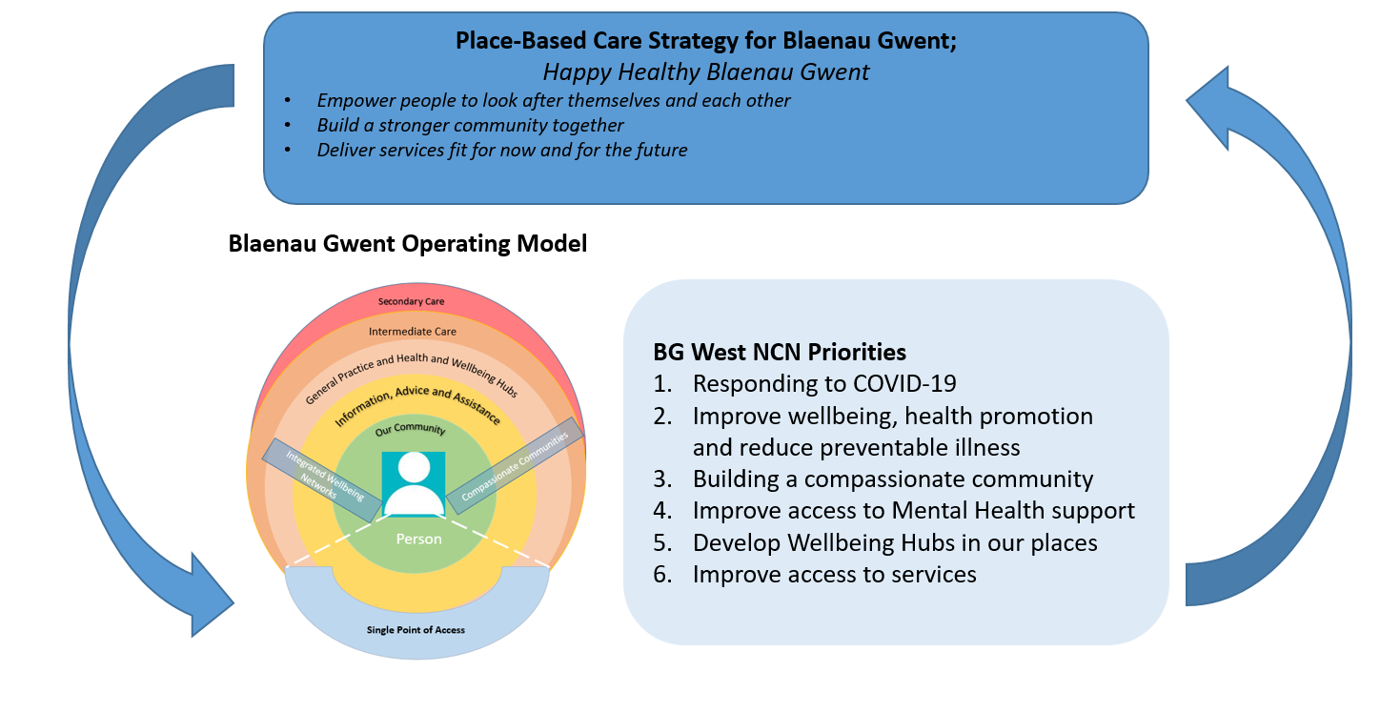

Introduction to the Plan
What is this section for?
Introduction to the document to be developed by Head of Service and NCN Leads, setting out its purpose and overarching ambition of the plan.

This document is the plan for the Blaenau Gwent West Neighbourhood Care Network.
It is a working and evolving document which is intended to set out not only our local plan for the Blaenau Gwent West Cluster, but also to reflect on our strengths and weaknesses.
We have always had the support of our wider NCN partners in striving to improve the health and wellbeing of the local population and these partners have been essential to the development of this plan.
It is hoped that this document provides background and supporting information to demonstrate our intentions over 2021-24, although as the 2020 Coronavirus pandemic has very clearly shown, we must also be able to collaborate, share and adapt.
This way of joint working is one of the fundamental principles of Cluster working within Wales.
Importantly, during 2020, the Blaenau Gwent Borough Team, NCN leads for both Blaenau Gwent East and West and Local Authority have worked in partnership to define our shared vision for Place-Based Care.
Our vision is to deliver a:
Happy, Healthy Blaenau Gwent
And our mission is to:
- Empower people to look after themselves and each other
- Build a stronger community together
- Deliver services fit for now and for the future

This vision and mission is delivered through our operating model.
The term Operating Model is used to describe at a high level how the health and care providers will work together to deliver health and wellbeing services in Blaenau Gwent.
In summary, our desired future state is that:
- We have a resilient community within each of our places
- We have a Health and Wellbeing Centre hosting primary, community, social and specialist services and at each of our places
- We have a single point of access for care navigation within our borough

The Blaenau Gwent model and its components are summarised below:

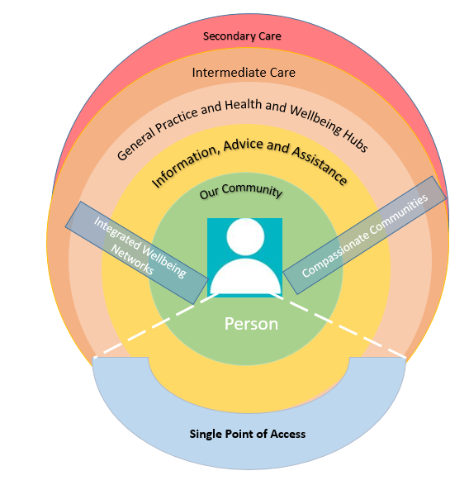
This clarity around our future vision and model provides a mutual opportunity, both for the Borough strategy to influence NCN plans and for the NCN plans to influence the Borough plans.
Both contribute to and align with one another.
In the next phase of development, we plan to further involve third sector partners and divisions of Health and the Council in developing our model for Blaenau Gwent.

Reflections on COVID-19 Pandemic Response

As the global covid pandemic began to escalate in March 2020, and it became clear that the threat to our health board population was increasing, we, as an NCN, set up weekly virtual calls to support one another to plan and respond to this new and unknown situation.
We immediately set up a ‘daily reporting’ email thread whereby each practice manager reported the numbers of suspected covid telephone calls and suspected covid face to face appointments, and also gave an indication of any staffing issues, worries or concerns. This enabled rapid escalation of issues to the Borough Team at an individual practice level, plus an overview of pressures across the NCN. We were the first NCN to commence daily data capture to inform decision making and to identify trends.
The Division directed the development of Borough Covid Assessment Centres, and all practices agreed to take part in the development and delivery of this new model despite anxiety and uncertainty around its proposed effectiveness as a solution to the anticipated peak in covid community transmission. Glyn Ebwy surgery was identified as the ideal facility to host this centre, and the practice kindly agreed to vacate their building and relocate to Ysbyty Aneurin Bevan.
The NCN worked together to develop the clinical model, a Standard Operating Procedure and a rota to staff the centre. The NCN Team ordered equipment and liaised with IT to ensure that each practice would be able to access any practice system from any practice location to aid business continuity should practices need to buddy. The NCN worked together to undertake a mock-up of a typical day within the building for staff who would be working there to aid familiarisation and streamline the experience for patients who may need to attend the centre.
The numbers of cases in the first wave did not reach a point that warranted the establishment of this arrangement; the NCN worked together to monitor the daily numbers and staffing pressures and reached decisions together on whether this arrangement needed to be initiated.
Whilst we did not need to implement the Covid Assessment Centre in Blaenau Gwent West during the first wave, we demonstrated our intention and ability to work together as a team for the good of our shared population, and it is reassuring that we now have a plan that we can take ‘off the shelf’ should numbers increase to a level where we feel that collaborative arrangements are needed to enable sustainability.
Through our regular communication and conversation as an NCN team, we were able to navigate the complex policies and procedures around social distancing, PPE and making buildings and services covid secure, and shared best practice and learning with one another.
One key piece of learning for us as an NCN has been importance of communication and engagement with our population. Our Integrated Wellbeing Networks (IWN) team joined our calls and were able to support us in ‘taking the temperature’ of the ‘mood’ of people in Blaenau Gwent West through their presence on many community social network pages.
Instead of seeing a rapid increase in contacts to primary care, we in fact experienced the opposite, and were unsure why this was the case.
Whilst certainly the result of number of factors, we received feedback from the IWN that many people were commenting online that they were afraid to access services due to the risk of covid and in compliance with the ‘stay at home message’, they were afraid of bothering the GPs during a difficult time and that they thought the GPs were ‘closed.’
We quickly responded to this issue by:
- Standardising practice website messages across the NCN to provide clarity on how to access services and when
- Developing a Blaenau Gwent video message, starring recognisable personalities from each of our GP surgeries, urging the public not to “wait until its too late” and that “we are here if you need us.”
- Developing a DVD with key messages including the GP message above for those who are unable to access the internet
We provided a pro-active and joint response, with the Local Authority for our patients who were shielding and vulnerable by promoting the Local Authority Hub Response, a service set up to support those struggling to access food or medication due to social isolation guidelines .Practices continued to use the Compassionate Communities Well-being calls model but with a refocus on proactively telephoning patients who were shielding to sign post to appropriate support.
The Combined Clinical Community Teams (CCCT) response as directed by the Division was straightforward to define in Blaenau Gwent given the existing close collaborative working between operational teams across health, local authority and independent partners:
- Social Care
- Community Resource Team (Rapid Response, Reablement, and Falls)
- District Nursing
- GP Practices/Health and Wellbeing Centres

Collaboration between the teams is enabled by:
- Single integrated health and social care team- the CRT
- MDT working at practice level, including GPs, ANPs, Pharmacists, therapists, community connectors, carers engagement officers, Hospice of the Valleys, GAVO and other third sector providers
- Single point of access to social care via the IAA
- Single management structure for CRT, District Nursing and Community Hospitals at a Borough Level (via Head of Service Role, Primary Care and Community)
- The NCN structure
- The District Nursing Service is also co-located with Social Care Services in Anvil Court, Abertillery, and the Vitecc Centre, Tredegar

During the first peak of the pandemic, when there were pressures upon staffing across the Borough, we were able to work together to merge and prioritise caseloads across the District Nursing and Rapid Teams to ensure timely access to care.

Subsequently, during November 2020 the Borough Team, GPs and Rapid Medical coordinated a response to a Local Authority Residential Home to support the medical needs of residents who had contracted covid-19.

These incidences have reassured us that we have the ability to work in partnership, across teams and organisations, at short notice/in response to continuity triggers, in line with the principles of our CCCT model.

The rapid roll out of Attend Anywhere and Microsoft Teams has enabled virtual assessments, handovers and business meetings to a scale that we hadn’t explored pre-pandemic, and challenged us to test as an NCN what absolutely requires face to face assessment and what can be safely and efficiently managed through the use of technology. We appreciate that this is a fine balance and we continue to work this through together from our own experience and in line with guidelines/evidence as they are published.

We are continually assessing if there are more efficient ways of communicating with patients and professionals alike; we appreciate that this is a continually evolving process and something that we are prepared to use funds towards trials and pilot options to enable the demands of new ways of working in Primary Care can be effectively delivered.

Ultimately, through responding to the pandemic together as a team, we have strengthened relationships and trust which will only aid progression of our NCN plans going forward.
The following fundamentals that supported our joint working are:
- Regular and open communication amongst the NCN members
- Tailoring communication to our local population utilising the IWN
- Standardising our message as an NCN where appropriate
- Maintaining the principles of Compassionate Communities and adapting these to the current challenges our patients face
- Using data to support our decision making
- ‘Taskforce’ approach across teams to address specific service pressures
These are areas of focus and key relationships that we will maintain and grow as we move in to 2021/2022.

Reflections on the 2020 – 2023 Plan

Whilst the context we work in has significantly changed since the writing of our inaugural NCN IMTP Plan, the principles that underpin it remain.
What we aim to achieve hasn’t changed but the means to which we might achieve it have adapted against a backdrop of continued social distancing, anticipated further lockdowns and the impact that this might have on our population’s access to the services they require and ultimately their well-being.
One of our biggest drivers is tackling social isolation and loneliness, and our 2020-2023 plan was based upon expanding our IWN and community groups within our places and increasing contacts and connections between people to benefit their well-being, in line with the Compassionate Communities ethos and model.
We have already adapted this by building communities online via the IWN, however we are conscious that there are members of our population who are hard to reach for a number of reasons, including that they don’t wish to engage with these communities or because they are digitally excluded.
Through the Compassionate Communities project, we will explore how to support different groups of people with different needs whilst our ability to gather in groups is limited.
Reflecting on last year’s plan, we have opted to consolidate our prioritised objectives from 8 to 6, keeping the essence of the plan but recognising that some of our original objectives overlap and thus making the plan sharper and more focussed.
Whilst included as an action within our last plan, we have highlighted ‘Improve access to Mental Health support for our population’ as a priority in its own right.
This is against a backdrop of our population needs assessment identifying that the Blaenau Gwent population has a poorer level of mental wellbeing than the average for Wales a whole and recognising the link between socio-economic deprivation and poor well-being/requiring treatment for mental health issues.
As well as introducing the Psychological Well-being Practitioner Role, we plan to work with Primary and Secondary Mental Health Teams and the third sector to understand how we can better meet the needs of our population.
We recognise the impact that covid19 could and will have upon the mental health of our population. Given that there are high instances of substance misuse amongst our population, we are bolstering our Compassionate Communities model through the transformation funded dedicated Blaenau Gwent IAA Drugs and Alcohol worker, and in doing so anticipate increased access to people for the support they require.
Learning from delivery of our initial plan so far, we believe that whilst improving GP training and retention across the NCN is critically important, our ability to influence this as an NCN in its own right is limited. Therefore we have changed the focus from this being a particular objective of the NCN and to an anticipated long term outcome of some of our other efforts that are within our control i.e. compassionate communities, development of well-being hubs. The NCN is actively looking at ways of getting our wider MDT involved in this process, promoting the training and placement work of the Academi and exploring this with particular focus on the two new Health and Well Being Centres being developed in the West. We are also focussed upon developing training practices in the NCN and aim to continually influencing HEIW in respect of seeking to increase the number of training Practices.

Delivery of the 2019/2020 plan at a glance
 | 2020-21 Priority | Progress | RAG | Going forward to 2021/2022 Plan
1 | Improve GP training, recruitment and retention | - Tredegar Health Centre appointed to consultant posts and Pen Y Cae has become a training practice.  - Sustainability RAG rating has improved in comparison to last year  - Transformation funded ANP now permanent staff member in Glan Rhyd | G | Remove as priority in own right as NCN has limited control; potential outcome of Compassionate Communities and well-being hub priority.
2 | Improve oral health in Blaenau Gwent West | - Due to covid19 pandemic, ability to progress plan has been significantly constrained | R | Remove as priority in own right but included as a key action within new priority “Improve wellbeing, health promotion and reduce preventable illness.”
3 | Improve the management of patients with chronic disease | - Home visiting service is embedding within the NCN and starting to demonstrate positive results- funding will continue in 2021/2022  - Additional session of EPP commissioned by the West | G | Remove as priority in own right but included as a key action within new priority “Improve wellbeing, health promotion and reduce preventable illness.”
4 | Build capacity of individuals to maintain good health and well-being by building on community development principles | - Delay in delivering original plans due to impact of covid19, however, have adapted plans within a covid19 context and increasing momentum during Q3  - Befriending service available across Blaenau Gwent  - Compassionate Communities Blaenau Gwent model co-produced by all practices and signed off  - Each practice has established MDTs, well-being phone calls and is building excellent relationships with their Link Worker  - MDTs have expanded to include members of CRT, drugs and alcohol worker and mental health support worker  - Commencing process for analysing frequent attenders to A+E and GP OOHs in Q3 | A | Consolidate in to one priority, “Building a Compassionate Community”
5 | Support people who may feel social isolated and frequent attenders of services |  | A
6 | Improve experience of people living with cancer, from prevention to diagnosis and living with the impact of cancer | - Progress impacted by Covid19 response | R | Remove as priority in own right but included as a key action within new priority “Improve wellbeing, health promotion and reduce preventable illness.”
7 | Improve a)childhood immunisation and b)vaccination uptake | - Top two NCNs for uptake of vaccinations for age 2-3 uptake.  - Top three NCNs for age 2-3 screening programme both reporting >90% uptake.  - Top for age 16 screening programme  - Improved on all screening programmes excluding cervical screening | G | Remove as priority in own right but included as a key action within new priority “Improve wellbeing, health promotion and reduce preventable illness.”
8 | Improve prescribing practice and reduce rates in line with best practice | - Progress constrained by focus on COVID19 response | A | Remove as priority in own right but included as a key action within new priority “Improve wellbeing, health promotion and reduce preventable illness

Summary of revised priorities
# | 2021/2022 Objectives | New/Rationalised
1 | Responding to COVID 19 | New priority  Responding to new context; requires focus
2 | Improve wellbeing, health promotion and reduce preventable illness | Rationalisation of existing priorities:  Improve cancer screening, immunisation and vaccination, prescribing rates
3 | Building a compassionate community | Rationalisation of existing priorities:  Build capacity of individuals to maintain good health and well-being by building on community development principles and support people who may feel social isolated and frequent attenders of services
4 | Improve access to Mental Health support for our population | New Priority  Included within existing priorities but requires own focus given PNA and anticipated impact of covid
5 | Develop well-being hubs in each of our places | New Priority  We recognise that a well-being hub is more than just ‘the building’ and are committed as an NCN to developing new ways of working to support this approach, collaborating with all partners including third sector organisations
6 | Improve access to services across the NCN | New Priority  Responding to new context re: Covid19; requires focus

Opportunities and Challenges for 2021-2024

SWOT Analysis

Strengths | Weaknesses
- Our partners share the same vision  - Excellent working relationships between Health, Independent Contractors, Local Authority and Third Sector  - Relatively ‘small’ borough which means we take advantage of close working relationships to deliver change quickly  - Strong sense of community  - Open and willing to try new and innovative models of care  - Loyalty and commitment to our population as many people both work and live within the community  - Low levels of Delayed Transfers of Care and effective patient flow through our hospital  - ‘One front door’ to social services via the IAA and we have IAA link workers embedded within our GP practices  - District Nursing Teams are aligned with each of our places  - Integrated Frailty Team and CRT  - CCCT contingency model is easily deployed due to existing relationships and infrastructure  - All West NCN Practices are able to work from any other Practice using their own Clinical System in the event of that business continuity arrangements are triggered | - GP sustainability; 1 managed practice in NCN footprint  - High levels of antibiotic and opioid prescribing and usage including pregabalin and gabapentin  - Oral health in Blaenau Gwent is worse in comparison with other areas  - People working and living in the Borough increases risk of staffing challenges during Covid-19 pandemic  - Lack of formal GMS buddying arrangements across the NCN  - Blaenau Gwent East and West Practices occupy the top 11 places across ABUHB for inappropriate ED attendances  - Performance has dropped for uptake on all screening (AAA, breast and cervical) excluding bowel, as a result of the COVID19 response  - Engagement and knowledge of third sector roles / resources
Opportunities | Threats
- Strengthen ability to deliver Place-Based care through:  -Development of Tredegar Health and Wellbeing Centre  -Development of business case to seek funding to deliver Ebbw Vale Health and Wellbeing Centre on Ysbyty Tri Chwm site  - Utilise Happy Healthy Blaenau Gwent Strategy and relationships to explore new models of care from across the UK and beyond  - Evaluate existing NCN funded posts and spend to support case for mainstreaming and free up budget for more innovative schemes  - Utilise expertise of NCN to develop innovative ideas and put them in to practice  - Promoting our new models of care as exemplars and attracting others to work with us  - Strengthen engagement with the community in designing the new models of care  - Upskilling of staff in social prescribing and care navigation  - Transferring what we know ‘works’ to core services/business as usual  - Utilise technology to improve patient experience and service efficiency including use of DEWIS and MySurgery  - Strengthen collaborative working between Primary Care and ED and GP OOHs to support those who are high impact users  - Exploration of GP direct admissions to YAB  - Dental practices are completing ACORNs, which will identify those patients most at need of intervention/care and encourage the development and use of pathways  - Strengthen NCN working as links have already been made  - Strengthen buddying arrangements and BCPs | - COVID19; threat to staffing, continuity and resilience of services, assess to secondary/primary services, increased A+E attendances, increased waiting lists and times and unknown impact in the long term  - Unknown impact of the opening of the Grange University Hospital upon other services and patients flows  - New models of care and ways of working are funded on short term WG transformation funding; ability to demonstrate value to make case for mainstreaming is crucial  - Ability to release funding from secondary settings to primary and community settings as a results of changes in flow  - Prevalence of long term chronic disease across the NCN  - Ability to deliver significant ‘shifts’ in activity within one- three year planning cycles (i.e. transformation takes time to realise in a material way)  - Dental access – practices are prioritising care/treatments at present which may cause backlogs and extended waiting times  - Dental PCR  - PPE constraints  - Optometry – many are small businesses which following C19 may not financially recover  - Brexit  - Sustainability / single handed practices  - Sustainability of third sector partners under current funding challenges

Driver Diagrams

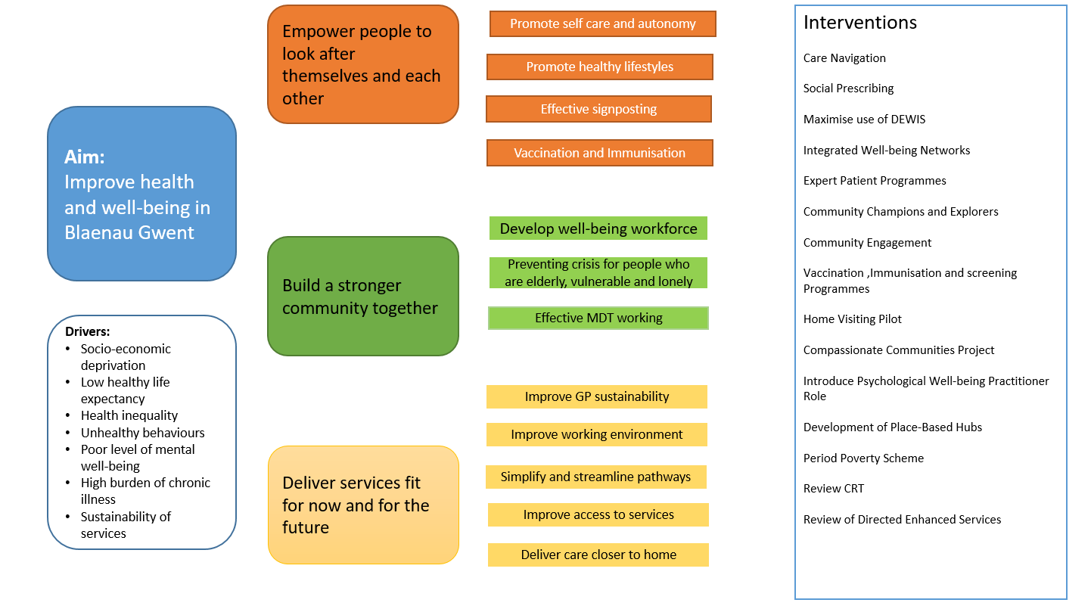

Prioritised Actions 2021-2024

# | Objective | Planned Actions | Anticipated Impact / Outcomes by March 2022 | Potential Constraints / Risks | Workforce & Financial Implications | Alignment to PNA and / or Strategic Driver
1 | Responding to COVID 19 | -Ensure buildings are covid secure  -Work with IWN to target communications to behaviours of our local population  -Readiness of response re: Covid Assessment Centres and Combined Clinical Community Teams at points of escalation  -Enhancing support for Care Homes during outbreaks  -Ensure support for those who have experienced Covid19  -Support and Test BCPs and Buddying arrangements  -Ensure continued provision of essential services (including F2F where necessary) | -All buildings are covid secure  -Our population are well informed of services available and how to access them  -Business Continuity Plans are strengthened and tested  -Taskforce approach deployed to escalating incidents within the NCN (i.e. outbreaks in care homes) | -Impact of community transmission on providing business as usual  -Risk that demand outstrips capacity  -Impact of people who have contracted covid in the long term is a significant unknown  -Impact of covid19 on wider determinants of health | -Cost of making buildings covid secure  -Responding to escalating issues in one part of the NCN will stretch resources in another | Divisional Deliverable:  Covid 19 Follow up and recovery
2 | Improve wellbeing, health promotion and reduce preventable illness | -Commission increased access to Expert Patient Programmes  -Undertake Flu vaccination programme  -Scope mass immunisation programme  -Support delivery of Covid vaccination programme  -Deliver Immunisation programme  -Increase Screening programmes  -Dental programme  -Review appropriateness of repeat prescription requests from community pharmacy with an emphasis on reducing medicines wastage. | -Increased referrals to EPP and improved self-management of chronic conditions  -Increased vaccination, immunisation and screening rates for population  -Increased uptake in screening programmes  -Improved oral health | -Public engagement in programmes within current covid environment  -Ability to deliver vaccinations across the NCN in a way that is covid secure  -Balancing priorities of delivering increased vaccinations alongside caseload and staffing challenges  -Supply chain for vaccinations | -Capacity of staff to deliver increased vaccinations plus existing case loads  -Cost of mass immunisation options in terms of facilities and staffing | Divisional Deliverable:  Preventable Poor Health and Wellbeing  BG West PNA:  - High chronic disease prevalence  - Low Immunisation and vaccination rates  - High use of Tramadol, and an overall Opioid burden  - One of the highest users of 4Cs antibiotics, and antibiotics in general  - Low uptake in screening and link between levels of social deprivation and cancer incidence  - Highest rates of tooth decay in children in Wales
3 | Building a compassionate community | -Implementation of Blaenau Gwent Model for Compassionate Communities  -Implementation of standardised data capture to quantify the benefits of the model  -Implementation of Care Navigation Pathway  -Implementation of Social Prescribing qualification following scoping of greatest area of need / impact  -Embed Home Visiting Service  -Gap analysis of community and third sector provision  -Integration of IAA Link Worker within practices  -Targeted approach to support patients who are frequent attenders to A+E/High Impact Users of OOHs  -Strengthen interface between practices and community development/ IWN  -Maximising use of DEWIS  -Development of case for mainstreaming service post-transformation funding  -Increase Community Champions and Explorers  -Focus upon engagement with those are digitally excluded  -Improved collaborative working between community pharmacy and other primary care providers.  - Continue funding the period poverty project to increase access to products for people who need them  - | -Consistent application of the CC model across Blaenau Gwent  Increase referrals to IAA Link Worker (number, reason, outcome)  Increase number of patients signposted using the service directory  Increased number of community champions  Increased referrals to EPP  Increase appropriate referrals for:  Drugs and Alcohol Worker  Mental Health Support Worker (IAA)  Domestic Violence Worker  Home Visiting Service  Increase number of appropriate referrals to rapid medical  Increased number of patients receiving a wellbeing call  MDT decision making for complex patients  Reduce the number of inappropriate frequent attenders to A+E  Reduce the number of in appropriate High Impact Users of GP Out of Hours  Improved staff morale | -Operational pressures/responding to increases in covid transmission in the community can redirect focus from service development work for those practices whereby the model has not been embedded  -Link Workers unable to be physically located within the GP surgeries | -Model supported by WG Transformation Funding which ceases in March 2022 ; case for mainstreaming required | Divisional Deliverable:  Workforce Wellbeing  Multi-disciplinary team working  Strategic Drivers:  Focus upon prevention and early intervention  Empower people to look after themselves and each other  Prudent health care- enable GPs to focus upon what only they can do  BG West PNA:  -Aging population  -Increasing number of people living alone  -High users of ED  -Increasing health inequalities
4 | Improve access to Mental Health support for our population | -Introduce Psychological Wellbeing Practitioners  -Implement Care Navigation Pathway  -Action plan to address gaps in service provision | Improved patient access to provision for ‘low level’ mental health issues  Creation of extra capacity by offering front line assessments for common mental health difficulties of low severity  Clear pathway for mental health provision | -Impact of covid19 upon mental health unknown  -Access to Primary and Secondary Care mental health services outside of the direct control of the NCN | -Funding for PWPs | Divisional Deliverable:  - Multidisciplinary Team Working  BG West PNA:  - Link between socio-economic deprivation and poor mental health  - Poorer level of mental wellbeing than the average for Wales a whole
5 | Develop well-being hubs in each of our places | -Tredegar- develop ways of working ahead of opening in Autumn 2022  -Ebbw Vale- develop business case for hub in YTC | -Tredegar Operational Model Developed  -Ebbw Vale Outline Business Case submitted to Welsh Government | -Delays to capital programmes/WG approvals due to impact of Covid19  -Community and third sector engagement re: change of service provision in Ebbw Vale | -Developing a ‘one team’ culture in the hubs | Divisional Deliverable:  - Estates Strategy  Strategic Driver  - Place-Based Care  - Care Closer to Home  BG West PNA  - Socio-economic deprivation and access to services  - GP sustainability
6 | Improve access to services across the NCN | - Implement plan to ensure full coverage of Directed Enhanced Services  -Implement plan to ensure that all care home residents are in receipt of care in line with Care Homes DES  -Development of recognised formal referral routes between primary care providers for service access.  -Work with health board to develop a digital strategy | -All Directed Enhanced Services are available across the NCN  -All Care Home residents are in receipt of care in line with the Care Home Des  -All practices have participated in the patient survey | -Agreement across practices |  | Divisional Deliverable:  Delivery of Enhanced Services at a Cluster Level

Monitoring Process

The Borough and NCN specific plans will be summarised into a set of Borough Delivery Milestones. These will be a combination of both actions mandated by the Division (as a result of nationally driven expectations) and actions specific to the borough/NCN as a result of a local population needs assessment. The aim of the Borough Delivery Milestones is to track the progress of Borough/NCN specific actions against a target deadline. The Delivery Milestones, and therefore the NCN Plans, will be reviewed on a quarterly basis through the Borough Assurance Meeting structure. Each Borough will be expected to periodically self-assess the status of their delivery plans utilising data made available to them.

In addition to this, the nationally derived actions and targets will assist in structuring the agenda of regular NCN Lead meetings, held monthly, to ensure NCN Leads are supported to meet set deadlines.

Estates Plan

Vision for Estates within the NCN

To implement our Place-Based model requires suitable estate:
- To facilitate the integrated model and the need to locate services together.
- To allow for the expansion of a multi-disciplinary team in Primary Care to manage demand appropriately and to ensure sustainability.
- To allow for the provision of Primary Care, appropriately “at scale” to ensure sustainability.

Health and Wellbeing Hubs allow such developments.
6.1.1 Vision for Tredegar
Development of a Health and Wellbeing Centre in Tredegar is a key priority for the Health Board.
A Full Business Case was submitted to the Aneurin Bevan Health Board for approval in September 2020 for onward submission to Welsh Government.
Welsh Government, as part of the business case development process, released funding for enabling works to be initiated following Outline Business Case approval, in parallel to the development of the Full Business Case.
The building is estimated to be open autumn 2022.
The Health and Wellbeing Centre will be home to:
- 2 GP practices; Glan Yr Afon and Tredegar Health Centre
- IAA link workers embedded within the team as the “one front door” to social services
- The following clinics will be available:
  - Podiatry
  - Audiology
  - Sexual Health
  - Health Visiting
  - Midwifery
  - CAHMs
  - Speech and Language
  - Paediatric Speech and Language
  - Gwent Drugs and Alcohol Services
  - Mental Health Support
  - Looked After Children
  - Memory Assessment Clinic

- There will also be opportunity to host a number of community groups relevant to the needs of the community, to include:
  - Fibromyalgia support
  - Befriending services
  - Women’s support groups

In addition there will be Pharmacy and Dental provision on site, and the Tredegar District Nursing Team, whilst currently based in the Local Authority owned Vitcc building, will relocate to the centre, to further promote the place based model of care.

6.1.2 Vision for Ebbw Vale
A scoping document proposing the formation of a Health and Wellbeing Centre in Ebbw Vale is in development between Health, Local Authority and Third Sector partners.
GP surgeries in Ebbw Vale are fully embracing the New Model for Primary Care and are building a multi-disciplinary team around their practices. However, the ability to reach their full potential and draw in the right services to meet the needs of the population is limited by available practice estate to accommodate these services/professionals.
The proposed site for the hub is Ysbyty Tri Chwm, which would require refurbishment to ensure it is fit for purpose.
The next steps are:
- Commence Outline Business Case April 2021
- Complete Outlined Business Case and WG approval January 2022
- Commence Full Business Case February 2022
- Complete Full Business Case and WG approval November 2022
- Commence Construction January 2023
- Complete Spring 2024

The Ebbw Vale Health and Wellbeing Centre will accommodate 3 GP surgeries:
- Pen Y Cae
- Glan Rhyd
- Glyn Ebwy
- Including their extended teams; IAA link worker, Advanced Nurse Practitioners, Practice Based Pharmacists

The centre will also house:
- Community Dental Services
- Community Pharmacy

And other services including but not limited to, and subject to review of Population Needs Assessment:
- Diabetic Eye Screening Wales
- AAA Screening
- Unpaid / Family Carers Support
- Gwent Drug and Alcohol Service (GDAS)
- Podiatry Services
- Audiology
- Mental Health and Counselling support from both Primary Care and our third sector consortium arrangements (Mind / Hafal/ Mindfulness Support etc.)
- Supporting People and Housing solutions
- Families First programmes
- Specialist Third Sector providers i.e. Dementia Support / Carers Support/ Hospice and Palliative care services
- Welfare and Benefit support – Job Centre / Department of Work and Pension/ Citizens Advice
- Social Care private providers including Domiciliary Care Agencies
- Domestic Abuse / VAWDASV services and promotion
- Aneurin Bevan Leisure Trust including Adult Education/ Healthy Living and Gentle Exercise support.

    - Cwm -Hub and Spoke Model
We anticipate that patients of Cwm GP surgery will be able to access the Ebbw Vale Hub for services/community groups that are not available within the village, on a hub and spoke model.

    - Our places, Tredegar and Ebbw Vale, have a wealth of community assets and buildings that our population can take advantage of. Working closely with our Community Development officer and IWN will support us to take a holistic approach to maximising our estate across the NCN.

Priority Developments

Our priorities for development are as follows:
Welsh Government Major Capital Funding
- Tredegar Health and Wellbeing Centre- Full Business Case submitted to Welsh Government
- Ebbw Vale Health and Wellbeing Centre- Outline Business Case to be submitted to Welsh Government by January 2022

Discretionary Capital Funding

- Cwm Health Centre-Cwm will be a ‘spoke’ of the Ebbw Vale Health and Wellbeing Centre and will require futureproofing; funding for a new boiler, blinds and fixing ‘buckling wall’ has been secured.

- Pen Y Cae Surgery will relocate to the Ebbw Vale Hub, however, given that this development has not yet been formally proposed via a business case, and the projection if approved is that the building will become operational in 2024, estates advice is required to ascertain whether the building can reasonably manage without work in the meantime.
Improvement Grants
- Both Glan Rhyd and Glyn Ebwy surgeries are committed to move to the Ebbw Vale Hub, however, given that this development has not yet been formally proposed via a business case, and the projection if approved is that the building will become operational in 2024, estates advice is required to ascertain whether the building can reasonably manage without work in the meantime.
Our prioritisation has focussed primarily on GMS and Well-being hub estate, but we aim to encapsulate dental and optom requirements in our next round of estates planning.

Workforce Plan

Current Workforce Profile

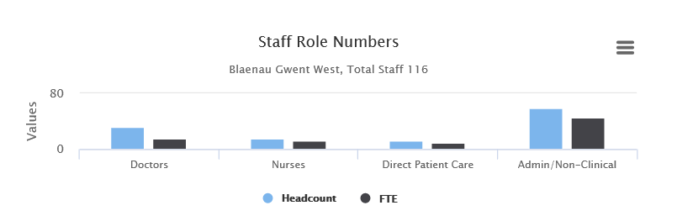
GMS- At a glance

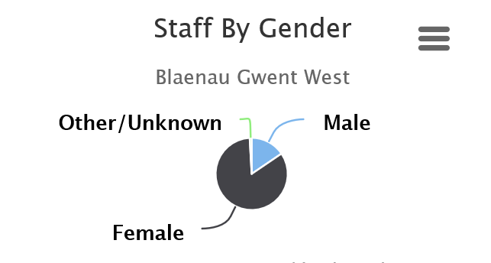

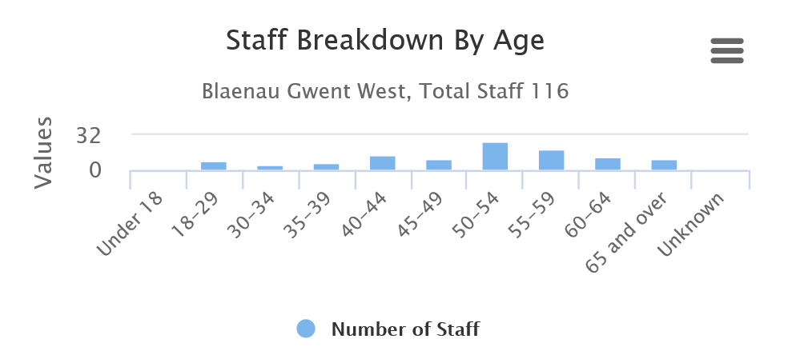

Workforce Risks & Drivers for Change

Sustainability of Primary Care, and in particular, recruitment and retention of GPs is a key challenge for the NCN.
Rapid implementation of the Primary Care Model for Wales, that is, enhancing of skill mix and ensuring that GPs are ‘only doing what only they can do’ has been a key priority of the NCN in the last 2 years and will continue to be during the foreseeable future.
The vehicle for developing larger multi-disciplinary teams around the practice, including new and extended roles such as Advanced Nurse Practitioners, Pharmacists, Physiotherapist, Paramedics, Mental Health Practitioners and Occupational Therapists, has been the Transformation Funded Compassionate Communities model and the enhancement of the IAA, social services and community provision.
Evaluating and embedding these roles, from short term funded posts to core establishment, is our key challenge as the Transformation Fund comes to an end in 2022.

Our vision in Blaenau Gwent West is that services are aligned with the following places:
- Ebbw Vale
- Tredegar
These services will be located within an integrated health and wellbeing centre in each place, as described within our estates strategy in the previous section, and will support with sustainability of services.
Our workforce plan in Blaenau Gwent aligns to our overarching Happy Healthy Blaenau Gwent (Place-Based Care) vision and the operating model that supports it.
This is a transformational model, and many of the posts testing and delivering this model are short term grant funded which poses an inherent risk to its delivery.
The HHBG Steering Group, comprising of the Borough Team, NCN Leads, Local Authority and NCN are committed to and focussed upon demonstrating the value of the model and developing a case for mainstreaming
Our Community
The Integrated Well-being Network have so far recruited 143 Well-being Champions across Blaenau Gwent, that is, volunteers who will support with sharing important information regarding COVID19, community based groups, events and support. These include members of the NCN such as Aneurin Leisure, GAVO and community members.
The next steps are to develop a 3 tier system involving not only community champions but Well-being Explorers and Well-being facilitators. Each tier is not exclusive community members can move from one tier to another dependent upon their individual interests and passions.

- Community Champions – community members who support the sharing of important information
- Community Explorers – Community members who are supported to actively engage with their friends, colleagues and social networks to identify gaps in support and local issues that impact upon health and wellbeing in the place they live.
- Community Facilitators – community members who actively work alongside professionals to implement solution to identified issues.

At the time of writing (November 2020) there has been no firm commitment to extend the Transformation funding of the Programme Team (1xWTE 8a, 0.2 xWTE Band 6, 0.6x WTE Band 5) who are leading the IWN beyond 2021, which poses a risk to implementation of this important element of the model.

The Community Development and DEWIS Officer, funded by Transformation funding, and sitting within the IAA Team, will be the interface between the GP practices, the IWN, champions/explorers and the community groups, supporting with identifying gaps in provision and crucially, ensuring that DEWIS is up to date to add with signposting
We are extremely lucky in Blaenau Gwent to be supported by GAVO and Hospice of the Valleys, who support us in delivering services within the community.
Information, Advice and Assistance
Blaenau Gwent Adult Social Services is a key partner within the NCN, with our particular interface being the Information Advice and Assistance Team who are the ‘one front door’ to adult social services.
The aim of the IAA is one of prevention; taking a ‘What Matters to Me’ approach to empower people to be happy and healthy, close to home, wherever possible, and only being signposted to health/statutory services when appropriate.
The team purpose is “We will be the first and single point of contact for adults living in Blaenau Gwent who require support to enhance their own wellbeing” and the team principles are:
- We will help you help yourself
- We will work together to provide ongoing support only when you need it
- We will provide consistency and avoid unnecessary ‘hand-off’s’ where possible.
A key component of our joint model is that each GP practice has an IAA Link Worker assigned to them, who becomes an integrated member of the team on the days allocated to that surgery and is a crucial member of the practice based MDT.
There are currently 7 GP Link Workers and 6 of those are funded through short term funding as follows:

- ICF – 3x full time, 1x part time
- Transformation – 2x full time, 1x part time
These posts will be evaluated as part of our case for mainstreaming by 2022.

GP Practices and Health and Well-being Hubs

We aim to implement Place Based Care and to enable citizens to receive as much of their care as possible within either their GP practice or a hub/centre which is close to their home.
GP Practices
The workforce vision to underpin this via the Compassionate Communities Model;
- MDTs are embedded within each practice
- Increased Care Navigation and Social Prescribing at the front desk of the practice
- Increasing opportunities for citizens to access social support from IAA Link Workers and reduce the reliance upon health services for social needs.
- Embedding new and extended roles to mitigate reduction in GP hours which will include; physiotherapy, mental health, advanced nursing practice etc
- Continuing to develop strategies to recruit GP’s in order to both increase sustainability and to reduce reliance on locums
- Embedding of Home visiting services

This work is currently funded via a combination of Transformation Funding and NCN funding, and roles need to be evaluated and embedded to business as usual to ensure sustainability of services.

District Nursing
The DN teams now aligned with the 4 places in Blaenau Gwent, and will be located within the Ebbw Vale and Tredegar Centres when operational over the next five years;
- District nurses to become active part of the hub approach that that is embedded within GP practices
- WCCIS is due to roll out to BG shortly and there will be an impact on DN services however at the moment this is difficult to quantify. Blaenau Gwent District Nursing Service is piloting the implementation of e-referrals and very early indication is that some time is saved by not needing to visit every practice every day to obtain referrals, however it is vitally important to ensure that key links and communication with practices are not affected.
- Development of catheter and HIC/PIC pathways to provide a clinic on Sirhowy ward to improve patient experience
- Consider whether District Nursing ANP role is the appropriate way forward or should this be achieved by integration with CRT
- Exploration of the neighbourhood nursing model

Ysbyty Aneurin Bevan

Ysbyty Aneurin Bevan (YAB) is a key part of the NCN’s service model, in ensuring that patients can remain as close to home as possible by either direct admission or by repatriation. The Outpatient service is also important in providing opportunity for patients to be seen as close to home as possible.

- Further develop Graduated Care to include the TEEM model (Therapy Enhanced Enablement Model) to provide care for level one/two patients and enhance the use of the Virtually Home beds particularly as a step up option.
- Develop a direct admission pathway to allow further options for patients to come into YAB rather than going to NHH first
- Enhance the palliative care CWTCH approach to ensure that patients in Blaenau Gwent have a full choice for management of symptoms and for end of life care.
- Further develop use of the Community Treatment Unit on Sirhowy working both with CRT and District Nursing.
- Continue to improve patient experience by reducing length of stay.
- Consider wider divisional work around the development of a rotational programme between hospital and community services
- Continue to develop the ANP model across both in hours and out of hours services using a training model including Band 6 and Band 7 staff however an 8a may become necessary to provide senior level leadership as the team expands.
- Consider development of a B4 HCSW role as part of the Nurse Led and Therapy Led models.

Intermediate Care

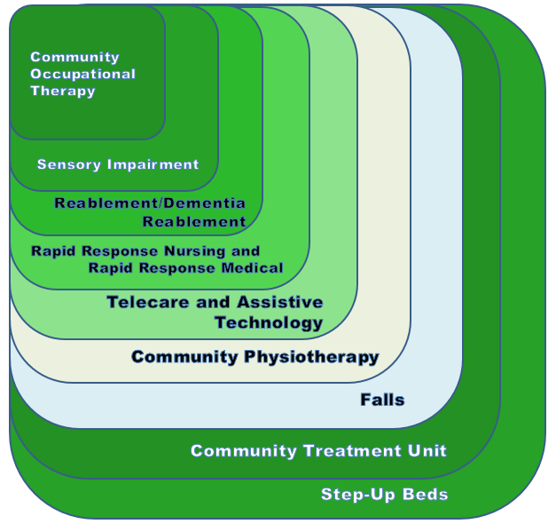
Community Resource Team
The Blaenau Gwent Community Resource Team (CRT) is a joint service provided by the Aneurin Bevan Health Board and Blaenau Gwent Social Services. The CRT provides help to adults, (over the age of 18) living in Blaenau Gwent who need support to stay independent, within their own homes.
The CRT is made up of:
- Health and Wellbeing support workers
- Rapid Medical
- Rapid Response Nurses
- Discharge Liaison Nurses
- Mental Health Nurses
- OT support workers
- Visual impairment support workers
- Rehab officer
- Speech and Language Therapists
- Telecare Assistive Technicians
- Senior Dieticians

Support the development of a place based care approach by ensuring that the CRT resource is based locally and has good links with both LA and GP colleagues
The CRT will:
- Embed CRT within the Compassionate Communities model
- Develop and implement a CATCH response to support Care Homes, learning from the Torfaen model
- Embed newly appointed Rapid Medical clinical team and review the hours of operation of the service to ensure balance between demand and clinical capacity.
- Ensure the opportunities of enhanced clinical roles are maximise, providing opportunity for GP’s to refer more patients in to the service and prevent patients being sent to an acute hospital by default.
- Develop a robust MDT approach to Rapid Medical/ Rapid other referrals incorporating Advanced Nurse Practitioners, Occupational Therapists, Physiotherapists and DASH.
- The DASH team will continue to integrate more fully with CRT to enhance the offer to GP’s of providing urgent care at short notice. A review will take place to understand if overnight support will be beneficial utilising short term pacesetter funding.
- The Therapy Enhanced Enablement Model (TEEM) on Tyleri ward will be developed in tandem with the Reablement team, proposing staff work rotationally between both services.
- Continue to develop the Community Treatment Unit and CRT beds on Sirhowy to prevent admission and provide care closer to home and include the development of a virtual ward round
- Support the development of the CRT pharmacy role as part of the Transformation bid.
- Developing an enhanced service provision for people with a diagnosis of Dementia.
- BetterCare - Working in collaboration with the local authority to develop a modernised approach to care handling, promoting people’s choice, creating a sustainable social care workforce and enhance training around care provision.

To achieve this vision we need to:

Develop prudent approach to maximising roles across all staff groups

- GP practice – embedding new roles, use of Link Workers, development of community structures

- Nursing – development of Band 3 and Band 4 HCSW roles to include therapy skills, enablement model and non-complex patient management

- Development of ANP model between areas ie hospital/CRT/District nursing to provide advanced practice in a synergistic way across all services

- Working with LA and third sector ensure that integration across all services is maximised to prevent handoffs and poor patient experience. Reduce barriers between services by strong management and leadership and development of robust pathways

- Consider how the planned integration of therapy staff from YAB into the CRT team is developed

- Development of rotational posts both to attract and retain staff but more importantly to ensure skills are appropriate for changing models, this must be underpinned by a robust training mechanism

- ANP – developing hospital ANP staff to be able to work confidently in and out of hours providing support to both the site and to the nurse led ward

- Consider the development of a more generic role across hospital and CRT with the potential implementation of a model that includes district nursing

- B5 nurses – develop a robust training programme that develops generalist skills across CRT, DNS and ward and a model of pool staffing that reflects this. Consider how this links to practice nursing

- HCSW – further develop the enablement model by staff working in hospital and across CRT

Training Requirements

The following training requirements have been identified in line with delivery of our model:
- Social prescribing and Care Navigation for receptionists, administrators and link workers
- Mentoring in Compassionate Communities’ model
- Domestic Violence training
- Mental Health First Aid training

Financial Plan

NCN Budget
1 | Spending vs Available Funding | 2021-22
 |  | £
 | Initial Allocation | 125,846
 | New 20-21 allocation | 128,167
 | Recurring funding | 254,013
 | Non-recurrent brokerage from 19-20 | 0
 | Total Available Funding | 254,013
 | Planned Spend | 253,669
 | Under / (over) Utilised | 344
 | % of Available Funding | 0.22
2 | Planned Spend summary | 2021-22
 |  | Total
 | Contributions to centralised services | £
 | Top Slice - Phlebotomy | 8,280
 | Top Slice - Independent Advisors | 2,460
 | Top Slice - Dementia Roadmap | 653
 |  | 11,393
 | Other
 | Practice Based Pharmacists | 91,576
 | First Contact Physiotherapy | 20,112
 | Mental Health - PWPs | 88,512
 | Home Visiting | 3,804
 | DEWIS | 1,507
 | COVID-19 - Premises | 16,582
 | Patient self-management | 8,000
 | Period Poverty | 2,160
 | CPD - Locum cover for Practices | 8,400
 | CPD - Course subscriptions / webinars | 1,600
 | Newt | 23
 | TOTAL SPEND PLAN | 253,669

A range of support for GP practices in Blaenau Gwent West have been recurrently funded, through central top slicing of the West NCN Budget allocation, which include specialist Advisor roles in Optometry, Dentistry and Pharmacy and investment in a Community Phlebotomy Service. They will continue to be funded in 2021/22.
The NCN continues to fund the two Practice Based Pharmacists in Blaenau Gwent West. The amount allocated this year represents purely salary costs.
Direct Access Physiotherapy Services at Ysbyty Aneurin Bevan have been supported by the NCN since 2016 – £69,605 has been invested in the Service from that date, including the funding allocation in this Spend Plan.
The appointment of the Psychological Well-Being Workers (PWP) in the NCN will have a full year affect for the first time in 2021/22. The impact of their full year cost is that there is less flexibility in the NCN budget to undertake additional initiatives identified by Members during 2021/22.
The Home Visiting Service has proven to be a success during 2020/21 and will continue to be funded for another Financial Year by the NCN.
During 2020/21, investment had been made by the NCN to support the developing Borough –wide Compassionate Communities Programme; this will be for training or initiatives that support implementation of the model at a wider NCN basis i.e. during 2020 we used this allocation for a social prescribing qualification to support NCN members.
An allocation has been made in the Spend Plan for the continued hire of PortaKabin and Marquees by the West NCN Practices. This is in anticipation of additional accommodation being required to enable suspected / confirmed COVID patients, as well as shielding patients, to be seen safely at Practices.
Expert Patient Programme (EPP) funding has been allocated to ensure additional non-clinical, local based education and support options are available for our local communities. EPP is seen as an integral element in the delivery of the Compassionate Communities Programme in Blaenau Gwent.
Our NCN initiative to support Period Poverty within the Borough, working alongside colleagues from the Local Authority and Voluntary Organisations is also recognised with continued funding for 2021/22.

During 2021/2022, we plan to evaluate long standing posts and commitments, and consider whether they are best funded from the NCN budgets or whether a case for mainstreaming is required, to free up the budget for spend on more innovative schemes.

Transformation Funding
Transformation funding has been utilised to support the implementation of the Place-Based Care model in Blaenau Gwent.
We are awaiting confirmation of allocation, but we are working on the assumption that we will receive the same allocation for 2021/2022 as a Transition Year of funding, recognising the time lost due to focus being upon the Covid pandemic response:
- 1 WTE Band 7 Service Development Lead (OT) to support implementation of the Compassionate Communities Model within each practice
- 1 Session for Compassionate Communities GP lead (Glan Rhyd Surgery) to provide clinical mentorship to each practice in regards to the compassionate communities model
- Locum backfill for each of the GP surgeries to provide headspace for the GP Lead to develop and implement the model within their practice
- Backfill for administrative staff to take on the role of Compassionate Communities Co-ordinators within each practice
- Community Connector Posts/Link Workers (social services)
We plan to scope a QI fellow post to replace the locum cover during q4 2020/2021.
We are developing a case for mainstreaming throughout 2021/2022, accepting that should term funding will come to an end in 2022. This case will be dependent on the quantification and realisation of benefits; this will be presented to the Transformation Delivery Group initially in Q3 2021/2022.

 | Monthly | Annual
Health Connector BG East | 2,333 | 27,996
Health Connector BG West | 2,334 | 28,002
Practice Based Internal Hub BG East | 7,405 | 88,860
Practice Based Internal Hub BG West | 8,473 | 101,676
GP Backfill Cover BG | 10,428 | 125,136
GP Mentoring BG | 3,033 | 36,400
OT Project Lead BG | 4,298 | 51,580
IAA: Service Prevention Manager BG | 5,510 | 66,120
IAA: Wellbeing Support Workers BG | 2,449 | 29,388
IAA: Substance Misuse Worker BG | 2,500 | 30,000

Strategic Alignment with Health Board Plans
The NCN IMTPs in Gwent have been produced in accordance with a range of local, regional and national objectives. As a result, the IMTPs are closely aligned to the overall strategic direction for Health and Social Care Services in Wales, described in both A Healthier Wales (2018) and Strategic Programme for Primary Care (2018).

National and Regional Plans
Following a review of national guidance, contractual obligations and Health Board objectives, the following priorities were identified to be reflected throughout all NCN IMTPs in 2021-22. These objectives have been embedded to ensure a degree of consistency, but with localised solutions and prioritisation of activities.
- Access to Services
- Quality Improvement
- COVID-19 Follow Up and Recovery
- Workforce Wellbeing
- Preventable Poor Health & Wellbeing
- Delivery of Enhanced Services at Cluster Level
- Community Eye Care Services
- Estates Development

Integrated Service Partnerships
As local partnership networks, the NCN IMTPs are guided by local population needs and aligned to the plans of each Integrated Services Partnership Board (ISPBs). As a result, they are both informed by the ISPB’s priorities and serve to influence the ISPB plans in the future in a cyclical manner. This IMTP aligns with the local objectives of the borough, which are described as follows:
- Responding to COVID19
- Improve wellbeing, health promotion and reduce preventable illness
- Building a compassionate community
- Improve access to Mental Health support for our population
- Develop well-being hubs in each of our places
- Improve access to services across the NCN

